Data Representation
Q1: Fill out the following table [6]
Decimal | Binary | Hexa-  decimal
48
 | 01101101
 |  | 2BE

Q2: Convert the following [6]

Text | 7 Byte Binary ASCII Code
NU-FAST

Q3: Represent the following in 2s compliment [8]
Integer | 1 Byte representation | 2 Byte representation
-14
14
30
-34

Q4: Represent the following in signed magnitude [4]
Integer | 1 Byte representation
55
-55
31
-31

Q5: What is the Maximum signed (sign magnitude) integer value that can be represented using 1 Byte? [2]
Q6: What is the Maximum unsigned integer value that can be represented using 2 Bytes? [2]
Q7: Fill the following for unsigned integers [6]
Integer | 1 Byte representation | 2 Byte representation
196
55
100015

Q7: If you have an RGB image of size 300x300 then how much space (in Bytes) it would take in computer memory? [2]

Week - Computer Organization and OS

- What will be the speed of 2.5 GHz processor in term of fetch-decode execute cycle? [2]
- What is the purpose of base register and bound register? [2]
- Complete the process state diagram, given the states of the processes. [5]
Ready
Waiting
Running
Terminated
New
- What is the difference between a process and a program? [2]
- What is the purpose of context switching? [2]
- What is the purpose of process control block? [2]
- Consider the set of 5 processes whose burst time are given below. Draw a Gantt chart to show turnaround time for RR CPU scheduling with time quantum of 2 units. Also fine the average turnaround time. [5]

Process Id | Service-Time
P1 | 6
P2 | 5
P3 | 2
P4 | 3
P5 | 7

- Given the following memory map, fill the following [5+5]

Size | First Fit | Best Fit
100KB
500KB
200KB
300KB
600KB

Job1 | Job2 | Job3 | Job4 | Job5
212KB | 417KB | 112KB | 426KB | 55KB

Database

      - Some tables are given with queries, identify the changes and update tables/database.

Networking
      - Add few questions

CG
Differentiate between Vector and Bitmap graphics. [2]
Differentiate between DIP and CG [2]

AI

1. Connect the table below [6]
- Knight’s Plight placement on the chess board
  - Planning
- Puzzle that involves calculation
  - Calculation, Computation, Reasoning
- spam mail filter
  - Unsupervised Learning
- Weather forecasting using previous year data
  - Supervised Learning
- Series Completion
  - Prediction
- Road Crossing
  - Rational Actions
- Weather forecasting using previous year data | - Planning
- Road Crossing | - Calculation, Computation, Reasoning
- spam mail filter | - Supervised Learning
- Series Completion | - Unsupervised Learning
- Knight’s Plight placement on the chess board | - Prediction
- Puzzle that involves calculation | - Rational Actions

Math
Given the graph below, use method discussed in class (dijkstra’s algorithm) to find the shortest path from the top left corner vertex/node (v1) to the bottom right vertex/node (v6). Label the vertices/nodes accordingly. Give the length of the shortest path. [6+2]
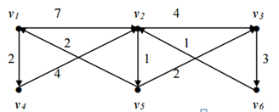

- Create adjacency matrix for the following graph. Assume that each link has weight 1. [4]
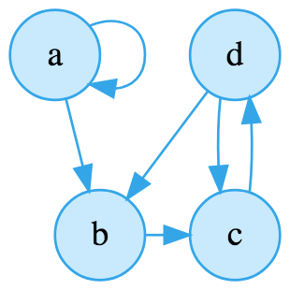

DATA Science

1. Differentiate between supervised and unsupervised learning with an example. [1+1+1]
2. Differentiate between classification and regression with an example. [1+1+1]

Internet

Create a simple html web page for the following specifications. [6+4]
- A text “A Simple Web Page” as heading.
- An image showing in the middle of the page.
- A paragraph explaining the purpose of the page.
- Set the color and font size of heading through by inline style.
- Set the color of paragraph by inline style.
- Set the margin of the link by inline style.

